DOI (To be completed by the editors)
SPACE
TITLE OF THE ARTICLE IN ENGLISH
WRITTEN ON A MAXIMUM OF 2 LINES
SPACE
TITLE OF THE ARTICLE IN ROMANIAN OR AUTHOR’S NATIVE LANGUAGE, WRITTEN ON A MAXIMUM OF 2 ROWS
SPACE
Surname NAME
SPACE
Institution
Author's Email
Author's ORCID number
SPACE
Abstract: Here the abstract of the article is introduced, keeping, as you can see, the term "abstract" with bold at the beginning. The abstract must have a minimum of 6 and a maximum 10 lines. Preferably 8-10 rows. Below, the keywords are necessarily separated by semicolons ";" not by single comma. The semicolon is also placed after the last keyword (for reasons related to the introduction of articles in CEEOL where it is required). In the case of all articles (including those in Romanian) it is mandatory that the abstract and the keywords are written in English!
Keywords: keyword; keyword; keyword;
SPACE
Introduction

This is where the text of the article begins. As you can see, subtitles can be put in the text, with the alignment as above, bold, the same size of the text, but they are not mandatory
As for the title of the article, if the article is written in Romanian (or another language besides English and Romanian), the second title will be in English. If the article is written in English, the second title will be mandatory in Romanian.
The abstract and keywords are always in English. Keywords are separated by semicolons ";", this sign is also placed after the last keyword.
The font used is Cambria, left-right spacing, size 11, spacing to 1.15; Each new paragraph starts with aligned. The pages of the material are not numbered!
There is always free space of one line between the subheadings and the corpus of text before and after it.

Subheading 1

The names of the subheadings have the same size and font as the text of the article, but they are bold, without alignment.
As for the musical examples, they are attached centered on the page, with a short text of the lamps below them, Cambria, 9, spacing 1 from the image, as in the example below.
Also, free space is left for one line before and after any musical examples, images, etc

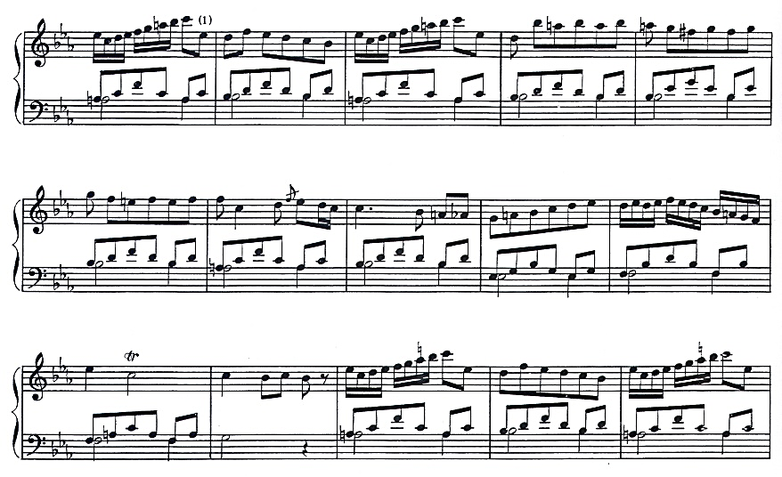
Musical Example No. 1 Detailing / Explaining the Example

Continuation of the text of the article. Citation of Bibliographic resources is done by footnotes, drafted in accordance with the norms in force of the Romanian Academy.

Conclusions
A well-drafted text is usually structured according to the international IMRaD format: Introduction, Methods, Results, Discussions. Also, the presence, clarity and synthesis of the conclusions are important elements of the census process.
References are mandatory. Without bibliography, the article is rejected Oficiu. The final bibliography is structured in accordance with the norms in force of the Romanian Academy. Please do not change the title "Bibliography/References" as it is used as standard in our publication.
Electronic references will be avoided as much as possible. If avoiding them is not possible, they will be used with great caution.

Bibliografie / References (Please do not change this title)

NAME, Surname, Title of the work, Publisher, City, Year
NAME, Surname, Title of the article in Publication title, No. 1 / 2026, Publishing House, City, Year.

ATTENTION!
In the case of articles written in English, the first title will be written in English and the second in Romanian. The Abstract and Keywords will always be written in English!

Failure to comply with this graphic format entails the return of the work to the author, in order to rearrange it in accordance with our graphic requirements.

For any other information: revart.journal@gmail.com

Surname, NAME, Title of the work, Publishing house, City, Year, p. 12 – 13 Or Surname, NAME, Title of the article in Title of the Journal, No. 3 / 2025, Publishing house, City, Year, p. 12 - 13

